**Sentiment Analysis on Twitter Data**

**(**CSE VI Semester Mini Project**)**

2023-24



**Submitted to: Submitted by:**

**Dr. Inderjeet Kumar**                         Shubham

(CC-CSE-K-VI-Sem) Roll No.-2118018

GEHU, D.Dun CSE-M-VI-Sem

**DEPARTMENT OF COMPUTER SCIENCE AND ENGINEERING**

**GRAPHIC ERA HILL UNIVERSITY, DEHRADUN**

**CERTIFICATE**

Certified that Shubham (Roll No.-2118018) has developed mini project on “ **Sentiment Analysis On Twitter Data**” .This project carried out by student is their own work as best of my knowledge.

Date: 13th July 2023

**Dr. Inderjeet Kumar**

**Class Co-ordinator**

**CSE-M-VI-SEM**

**(CSE Department)**

**GEHU Dehradun**

**ACKNOWLEDGEMENT**

I would like to particularly thank my Class Co- **Dr. Inderjeet Kumar** for his patience, support and encouragement throughout the completion of this project.

       At last, but not the least I greatly indebted to all other persons who directly or indirectly helped me during this course.

**Sagar Chandra Kalauni**

**Univ. Roll No.- 2018678**

**B.Tech CSE-K-V-Sem**

**Session: 2022-2023**

**GEHU, Dehradun**

**TABLE OF CONTENT**

1. **INTRODUCTION**
   1. What is Sentiment Analysis?
   2. About Project
2. **REQUIREMENTS OF PROJECT**
   1. Software Requirements
   2. Libraries
3. **OUTPUT**
4. **CONCLUSION**
5. **REFRENCES**

**INTRODUCTION**

[Sentiment analysis](https://monkeylearn.com/sentiment-analysis/) is the automated process of identifying and classifying subjective information in text data. This might be an opinion, a judgment, or a feeling about a particular topic or product feature.

The most common type of sentiment analysis is ‘polarity detection’ and involves classifying statements as Positive, Negative or Neutral

**About project**

Sentiment analysis uses [Natural Language Processing (NLP)](https://monkeylearn.com/natural-language-processing/) to make sense of human language, and [machine learning](https://monkeylearn.com/machine-learning/) to automatically deliver accurate results.

Connect sentiment analysis tools directly to your social platforms, so you can monitor your tweets as and when they come in, 24/7, and get up-to-the-minute insights from your social mentions.

**REQUIREMENTS OF PROJECT**

* 1. Software Requirements
* Visual Studio Code IDE

Version: 1.68

* Python

Version : 3.10.4

* 1. Libraries
* Tweepy : easy-to-use Python library for accessing the Twitter API.
* Textblob: TextBlob is a Python (2 and 3) library for processing textual data. It provides a simple API for diving into common natural language processing (NLP) tasks such as part-of-speech tagging, noun phrase extraction, sentiment analysis, classification, translation, and more.
* Tweepy.streaming : The Twitter streaming API is used to download twitter messages in real time. It is useful for obtaining a high volume of tweets, or for creating a live feed using a site stream or user stream.

**OUTPUT**

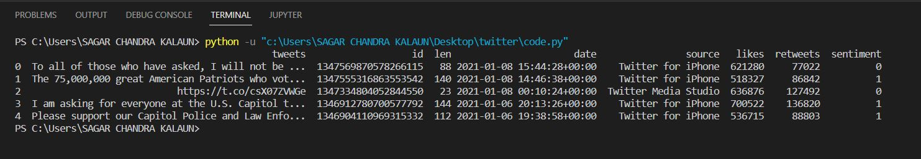

This is output of sentiment analysis on the tweets done by Donald J. Trump.

**CONCLUSION**

I have successfully created a code that can access data from the twitter application and analyse the sentiments of the tweets.

I this ,I learned how to install certain libraries and link them to python, how to work with twitter libraries.

Sentiment analysis helps data analysts within large enterprises gauge public opinion, conduct nuanced market research, monitor brand and product reputation, and understand customer experiences. In addition, data analytics companies often integrate third-party sentiment analysis APIs into their own customer experience management, social media monitoring, or workforce analytics platform, in order to deliver useful insights to their own customers.

**REFRENCES**

[U tube](https://chatterbot.readthedocs.io/en/stable/index.html)

Google